THE SESE80 80 METER SSB RECEIVER

By PAUL DAULTON K5WMS

Feb. 5 2011

Index

Introduction……………………………………………………… 2

Assembly…………………….…………………………… 2 and 3

Alignment……………………………………………………… 4

Wiring to P C Board ………………………………………….. 5

Parts List………………………………………………………. 6

Schematic……………………………………………………… 7

Pictures ……………………………………………………….. 8 and 9

Color Code Designations……………..……………………….9

Biography ……………………………………………………………….10

Introduction

The SESE80 is an 80-meter SSB single conversion amateur radio receiver covering 3.5 to 4.0 MHz. Transistors and discrete components were used instead of the conventional IC mixer to achieve the desired performance. There are two tuned circuits, T1 and T2 in the front end to give greater out side of the band rejection. The first IF and mixer consist of Q1, Q2, and Q3. The first oscillator (the VFO) tunes from 6.0 to 6.5 MHz with a course tune via VR2 and a fine tune via VR9 for excellent selective. For excellent selectivity, a four pole crystal filter is used in the IF. The second oscillator is Q8 at 10 MHz and feeds into the product detector consisting of Q4, Q5, and Q6. Audio gain is supplier by the LM386 IC for driving headphones, 8 ohm, or 16-ohm speaker. Voltage regulation for stability of the two oscillators is done with a 78L05 IC.

Assemble
Assembly of the SESE80 can be an easy task with a little preparation.

First inventory the parts and segregate them. A styrofoam block is a convenient way to sort and store the parts prior to assembly. If you are missing any parts or if any of the parts are broken, please email FAR Circuits for replacements. Note that the resistors may be 10% and 5%. The 10% resistors have tan body and the four band value color code. The 5 % resistors have a blue body and have a five band value color code.

Second, prepare the cabinet before installing the parts on the circuit board. An enclosed metal cabinet is recommended. Two of the prototypes were built in Bud Industries 2x6x8 chassis. Bud part no. AC1413, Mouser P/N 563-AC1413. Check for clearance of the controls and location of the main board before drilling. Use the P C board before mounting any parts to mark the location of the P C board mounting holes. The cabinet can be drilled, painted and labeled (except main or course tuning, this must wait until final alignment) then set the cabinet aside.

Third, remove the capacitors from the coils T1, T2, and T3.and discard the capacitors. Crushing the caps with a jeweler’s screwdriver can do this. Install the components in the circuit board starting with the resistors, diodes, capacitors, and the rest of the parts. Do not install the LM386 until after the voltage check and be made in the alignment section. Go at a leisurely pace, insert 5 or so components stop and solder them and trim the excess leads. The components especially the resistor and capacitors should fit all the way against the board. If a component does not sit against the board after soldering the part, unsolder one pad at a time one straightens the part. Moving a part without relieving the stress by unsoldering the lead from the pad may result in a detached pad. Installed the 8 pin IC socked for the LM386 but do not install the LM386 until the assemble is complete and preliminary voltage measures and made.

. Make sure the electrolytic capacitors are installed with correct polarity. The plus (+) lead is longer and there is a strip on the body of the capacitor indicating the minus (-) lead. The P C board is marked with a plus (+) sign where the positive (+) lead in inserted. Take care to keep the 470 uh choke and the 470 resistor segregated. They have the same color code, but the choke has blue body and the resistor has a tan body. Use an ohmmeter if in doubt. The resistors and the capacitors are packed in separate bags.

After all the parts are installed, solder the leads for power, antenna, volume, and tuning controls to the circuit board Install the board in the cabinet using the 1/4 inch spacers and #4 hardware supplied for mounting the p c board to the cabinet.

Next connect for the wires to the controls, antenna, power, and speaker. Two conductor-shielded wire is supplied for connection of the volume control to the P C Board. The antenna connection to the P C board should be made with a short length of 50-ohm coax.

SESE80 is designed to use 9 to 12 volts via red and black supplied wires. You may elect to install your favorite power jack for convenience. It is recommended to use 12v from a regulated and well-filtered power supply. A “wall wart” DC source is not suitable. Most of these wall warts are unfiltered and unregulated. Use a good 3 or 4 inch speaker. A 4-inch CB extension speakers or external computer speaker is ideal. The CB extension speakers are sold at most truck stops or at the Electronic Surplus suppliers.

Alignment
Voltage Check, apply power to the power jacks. Check that there is the supplied voltage on the collector of Q1and pin 6 of the socket for the LM386. Then check there is 5 v on the collector of Q7 and Q8. With successful voltage measurements, remove power and install LM386.

Set the VFO fine tune pot to mid range and install the knob pointing to 12 o’clock. Set the course tune to CW stop and install knob pointing to 5 o’clock. Turn course tune back to 3 o’clock and adjust VFO coil T3 for a VFO frequency of 6.500 MHz. (received frequency of 3.500 MHz) This can be determined by listening to the VFO on a general coverage receiver or injecting a 3.500 MHz signal into the antenna jack. Rotate the course tune back to 9 o’clock the VFO should be about 6.000 MHz (received frequency of 4.000 MHz). Label the 4.0 and 3.5 MHz points and the 100 kHz marks in between.

Front-end alignment, connect an antenna, set T1 for maximum background noise at 3.9mhz, and set T2 for maximum background noise at 3.7mhz. If SW broadcast feed through is heard, then T2 is adjusted too far down. If this occurs, turn T2 CCW a couple of turns and re-peak T1.

BFO alignment. Tune down in frequency across a steady carrier. The correct frequency for the BFO is when the carrier drops out at about zero beat. Adjust C36 to change BFO frequency.

P C BOARD INTERCONNECT WIRING
VOLUME CONTROL
REAR VIEW

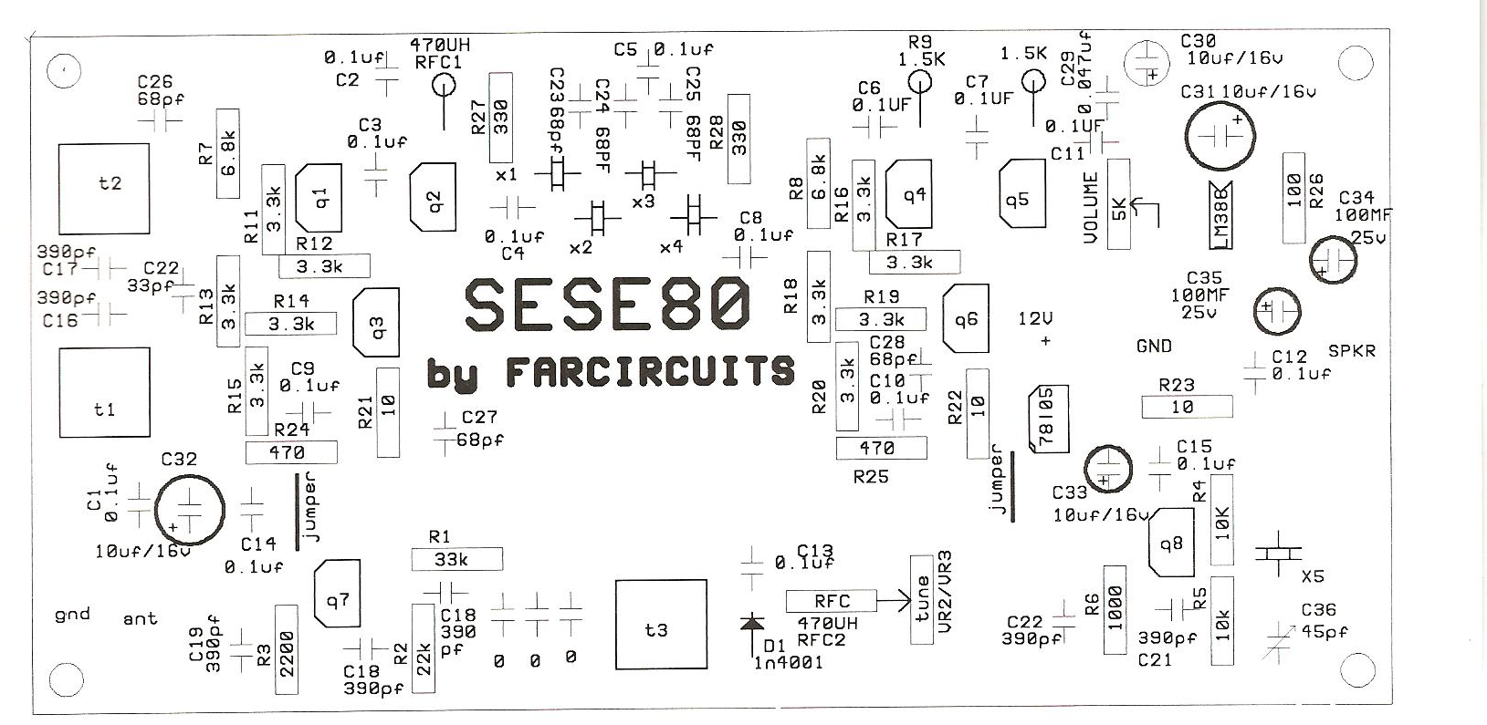
COAX
GND
+12 DC
TO ANTENNA
AUDIO
GND
COURSE TUNE
FINR TUNE
REAR VIEW OF CONTROLS CONTROLS
+5V
GND
WIPER

2 WIRE SHIELDED

PARTS LIST

DESIGNATION | DESCRIPTION/MARKING | PART #
T1, T2, T3 | 10.7 MHZ IFT | 42IF123-RC
Q1 THRU Q8 | 2N3904 | 2N3904
U1 | 78L05 TO92 PACKAGE | 78L05ACPRAG
U2 | LM386 8 PIN DIP | NJM386D
X1 THRU X5 | 10 MKZ CRYSTAL | FOX100-20-LF
C1 THRU C15 | .1 UF DISC LABELED AS 104 | SR2115E104MMA
C16 THRU C21 | 390 PF COG BLUE, NO MARKING | K391J15COGF53L2
C22 | 33 PF COG BLUE BODY 33 | RPE5C1H
C23-C28 | 68 PF COF BLUE BODY NO MARKING | FK28COG1H680J
C29 | .047 UF | 140-50Z5-472M-RC
C30-C33 | 10 UF 16V | UVR1E100MDD
C34-C35 | 100 UF 25V | B41827A5107M00
C36 | 50 PF TRIMMER | 659-GKG50015
D1 | 1N4001 | 512-1N4001
R1 | 33K ¼ COLOR CODE OR-OR-OR-GD | 291-33K-RC
R2 | 22K 1/4 W COLOR CODE RD-RD-OR-GD | 291-22K-RC
R3 | 2200 1/4 W COLOR CODE RD-RD-RD-GD | 291-2.2K-RC
R4, R5 | 10K 1/4 W COLOR CODE BR-BK-OR-GD | 291-10K-RC
R6 | 1000 1/4W COLOR CODE BR-BR-RD-GD | 291-1K-RC
R7,R8 | 6800 1/4 W COLOR CODE BL-GY-RD-GD | 291-6,8K-RC
R9- R10 | 1500 1/4 W COLOR CODE BR-GN-RD-GD | R291-1.5K-RC
R11 THRU R20 | 3300 1/4 W COLOR CODE OR-OR-RD-GD | 291-3.3K-RC
R21 THRU R23 | 10 1/4 W COLOR CODE BR-BK-BK-GD | 291-10-RC
R24 R25 | 470 1/4 W COLOR CODE YL-VI-BR-GD | 291-470-RC
R26 | 100 1/4 W COLOR CODE BR-BR-BR-GD | 291-1K-RC
R27- R28 | 330 1/4 W COLOR CODE OR-OR-BN-GD | 291-330-RC
RFC1-RFC2 | 470 UH YL-VO-BR-GD BLUE BODY | 542-78F471-RC
VR1 | 5K AUDIO TAPER | RV120F-10-15F-A5K
VR2 | 100K AUDIO TAPER | RV120F-10-15F-A100K
VR3 | 5K LINEAR TAPER | RV120F-10-15F-L100K
J1 | SPEAKER JACK 1/4" | 161-MJ159M-EX
J2 | PWR JACK 5.5 MM/2.1MM | 163-4304-E
J3 | SO239 ANTENNA CONNECTOR | USER SUPPLIED
 | KNOBS | USER SUPPLIED
 | 12V DC POWER SUPPLY | USER SUPPLIED
 | CABINET | USER SUPPLIED
UNMARKED PARTS ARE INDIVIDUALLY PACKAGED AND LABELED

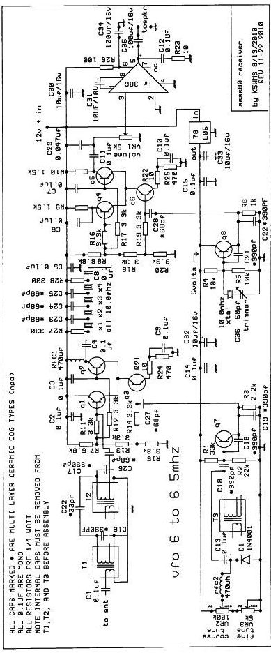

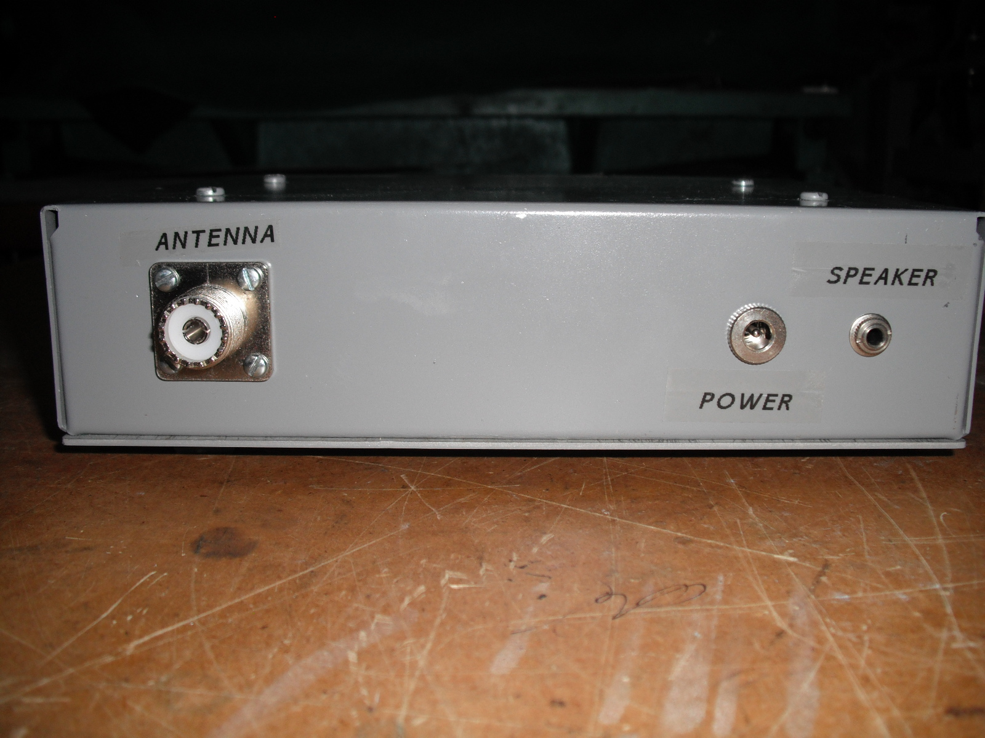

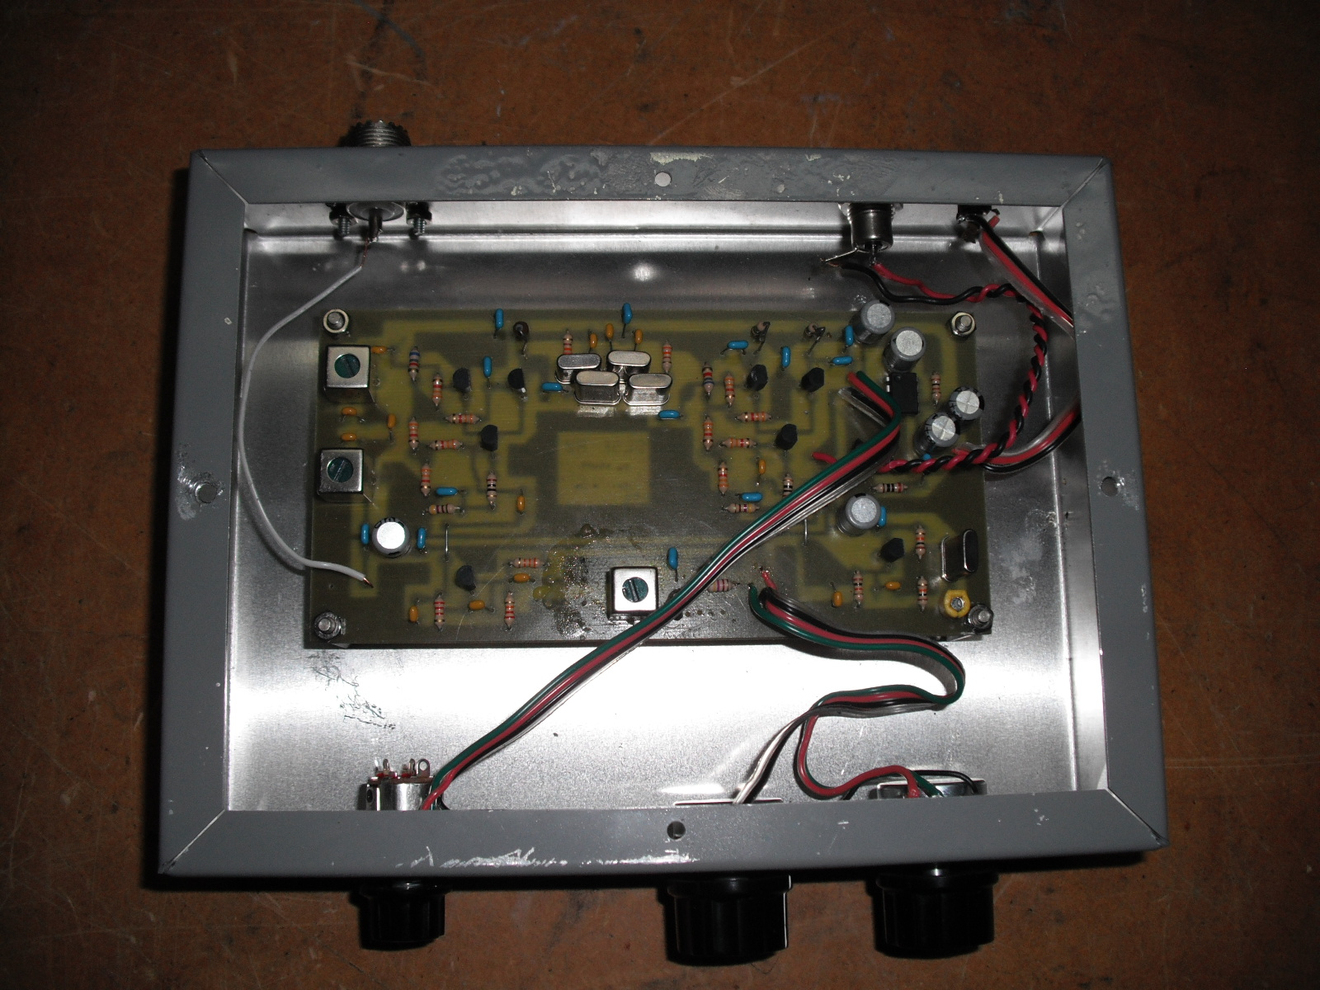

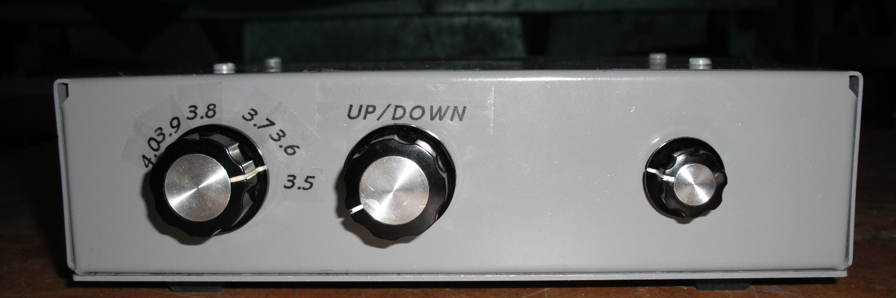

Resistor color code designation

Black 0
Brown 1
Red 2
Orange 3
Yellow 4
Green 5
Blue 6
Violet 7
Gray 8
White 9
Silver 10%
Gold 5%

Biography

Paul Daulton was licensed in 1959 and holds an Advance Class licenses

Published in:
73’s August 1992 The Explorer Receiver
73’s October 1995 The Traveler Receiver
Designed the Centennial SSB transceiver for Dan’s Small Parts and Kits

